**EV BATTTERY SALES SQL QUERIES**

**A. KPI’s**

**1. Total Revenue:**

SELECT SUM (total price) AS Total_Revenue FROM ev_batteries;

**2. Average Order Value**

SELECT (SUM (total_price) / COUNT(DISTINCT order_id)) AS Avg_order_Value FROM ev_batteries;

**3. Total Batteries Sold**

SELECT SUM (quantity) AS Total_batteries_sold FROM ev_batteries;

**4. Total Orders**

SELECT COUNT (DISTINCT order_id) AS Total_Orders FROM ev_batteries;

**5. Average Batteries Per Order**

SELECT CAST(CAST(SUM (quantity) AS DECIMAL(10,2)) /

CAST (COUNT(DISTINCT order_id) AS DECIMAL(10,2)) AS DECIMAL(10,2))

AS Avg_Batteries_per_order

FROM ev_batteries.

**B. Daily Trend for Total Orders**SELECT DATENAME (DW, order_date) AS order_day, COUNT(DISTINCT order_id) AS total_orders

FROM ev_batteries

GROUP BY DATENAME (DW, order_date)

***Output:***

**C. Monthly Trend for Orders**

select DATENAME(MONTH, order_date) as Month_Name, COUNT(DISTINCT order_id) as Total_Orders

from ev_batteries

GROUP BY DATENAME(MONTH, order_date)

***Output***

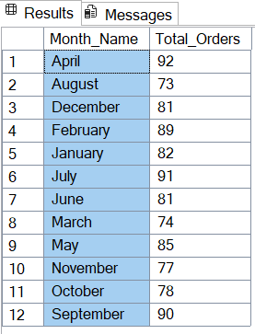

**D. % of Sales by Battery Category**

SELECT battery_category, CAST(SUM(total_price) AS DECIMAL(10,2)) as total_revenue,

CAST(SUM(total_price) * 100 / (SELECT SUM(total_price) from ev_batteries) AS DECIMAL(10,2)) AS PCT

FROM ev_batteries

GROUP BY battery_category

***Output***

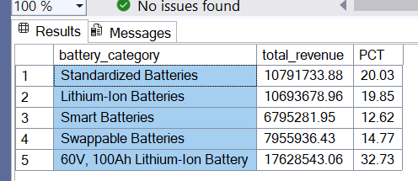

***-***

**E. % of Sales by Battery Size**

SELECT battery_size, CAST(SUM(total_price) AS DECIMAL(10,2)) as total_revenue,

CAST(SUM(total_price) * 100 / (SELECT SUM(total_price) from ev_batteries) AS DECIMAL(10,2)) AS PCT

FROM ev_batteries

GROUP BY battery_size

ORDER BY battery_size

***Output***

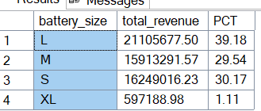

**F. Total Batteries Sold by Battery Category**

SELECT battery_category, SUM(quantity) as Total_Quantity_Sold

FROM ev_batteries

WHERE MONTH(order_date) = 2

GROUP BY battery_category

ORDER BY Total_Quantity_Sold DESC

***Output***

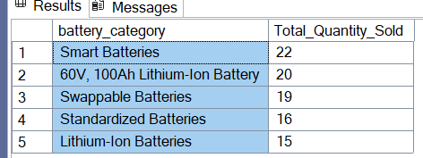

**G. Top 3 Batteries by Revenue**

SELECT Top 3 battery_name, SUM(total_price) AS Total_Revenue

FROM ev_batteries

GROUP BY battery_name

ORDER BY Total_Revenue DESC

**H. Bottom 3 Batteries by Revenue**

SELECT Top 3 battery_name, SUM(total_price) AS Total_Revenue

FROM ev_batteries

GROUP BY battery_name

ORDER BY Total_Revenue ASC

**I. Top 3 Batteries by Quantity**

SELECT Top 3 battery_name, SUM(quantity) AS Total_Battery_Sold

FROM ev_batteries

GROUP BY battery_name

ORDER BY Total_Battery_Sold DESC

***Output***

**J. Bottom 3 Batteries by Quantity**

SELECT TOP 3 battery_name, SUM (quantity) AS Total_Battery_Sold FROM ev_batteries GROUP BY battery_name ORDER BY Total_Battery_Sold ASC

***Output***

**K. Top 3 Batteries by Total Orders**

SELECT Top 3 battery_name, COUNT (DISTINCT order_id) AS Total_Orders

FROM ev_batteries

GROUP BY battery_name

ORDER BY Total_Orders DESC

**L. Bottom 3 Batteries by Total Orders**

SELECT Top 3 battery_name, COUNT (DISTINCT order_id) AS Total_Orders

FROM ev_batteries

GROUP BY battery_name

ORDER BY Total_Orders ASC

***NOTE***

If you want to apply the battery _category or battery _size filters to the above queries you can use WHERE clause. Follow some of below examples.

SELECT Top 5 battery _name, COUNT (DISTINCT order_id) AS Total_Orders

FROM ev_batteries

WHERE battery _category = 'Classic'

GROUP BY battery _name

ORDER BY Total_Orders ASC